INC4705805
Issue: Unable to Reverse TO Due to Batch
User requested to remove the following linkage in the delivery 149665986
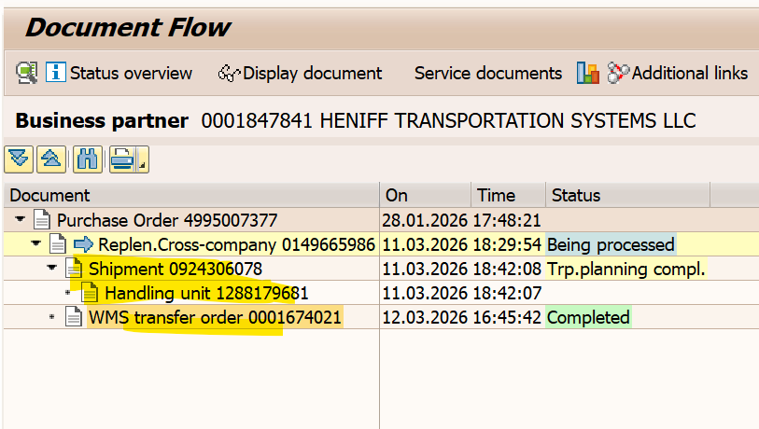

We remove the following linkage by doing ANIS request. Table entry vbfa was deleted and the status of the delivery was made to A by running zzdelsta program in transaction se38.

User confirmed that the issue was resolved and agreed for ticket closure.

